**Project Design Phase-II Data Flow Diagram & User Stories**

|  |  |
| --- | --- |
| Date | 06 November 2022 |
| Team ID | PNT2022TMID46479 |
| Project Name | Customer Care Registry |
| Maximum Marks | 4 Marks |

**Data Flow Diagrams:**

A Data Flow Diagram (DFD) is a traditional visual representation of the information flows within a system. A neat and clear DFD can depict the right amount of the system requirement graphically. It shows how data enters and leaves the system, what changes the information, and where data is stored.

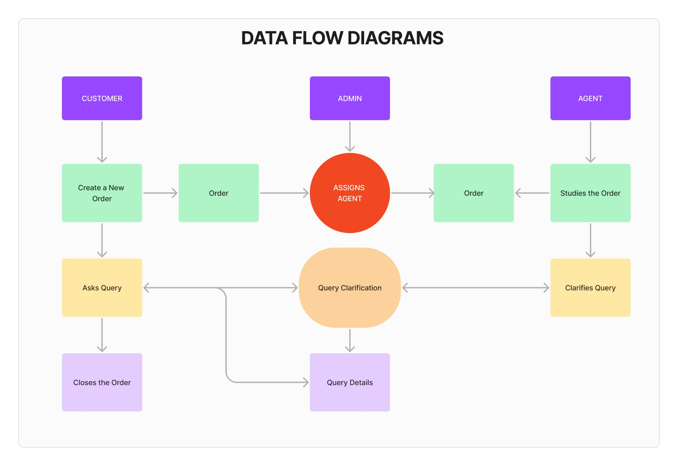

**User Stories**

|  |  |  |  |  |  |  |
| --- | --- | --- | --- | --- | --- | --- |
| **User Type** | **Functional**  **Requirement**  **(Epic)** | **User Story**  **Number** | **User Story / Task** | **Acceptance criteria** | **Priority** | **Release** |
| **Customer**  (Mobile user and Web User) | **Registration** | USN-1 | As a Customer, I can register for the application by entering my email, password, and confirming my password. | I can access my account / dashboard | High | Sprint-1 |
|  | **Login** | USN-2 | As a Customer, I will receive a confirmation email. | I can receive confirmation email & click confirm | High | Sprint-1 |
|  | **Dashboard** | USN-3 | As a Customer, I can see all the orders raised by me. | I can get all the info needed in my dashboard. | Low | Sprint-2 |
|  | **Order Creation** | USN-4 | As a Customer, I can place my order with a detailed description of my query. | I can ask my query. | Medium | Sprint-2 |
|  | **Address Column** | USN-5 | As a Customer, I can have conversations with the agent and get my queries clarified. | My queries are clarified. | High | Sprint-3 |
|  | **Forgot Password** | USN-6 | As a Customer, I can see the current status of the order. | I can get access to my account again. | Medium | Sprint-4 |
|  | **Order Details** | USN-7 | As a Customer, I can see the current status of the order. | I can get a better understanding. | Medium | Sprint-4 |
| **Agent**  (Web User) | **Login** | USN-1 | As an agent, I can Login to the Application by entering correct login credentials. | I can access my account / dashboard | High | Sprint-3 |
|  | **Dashboard** | USN-2 | As an agent, I can see the order details assigned to me by the admin. | I can see the tickets to which I could answer. | High | Sprint-3 |
|  | **Address column** | USN-3 | As an agent, I can have conversations with the customer and clear their doubts. | I can clarify the issues. | High | Sprint-3 |
|  | **Forgot Password** | USN-4 | As an agent, I can reset my password by this option in case I forgot my password. | I can get access to my account again. | Medium | Sprint-4 |
| **Admin**  (Web User) | **Login** | USN-1 | As an admin, I can Login to the Application by entering correct login credentials. | I can access my account / dashboard | High | Sprint-1 |
|  | **Dashboard** | USN-2 | As an admin, I can See all the orders raised in the entire system and a lot more. | I can assign agents by seeing those orders. | High | Sprint-1 |
|  | **Agent Creation** | USN-3 | As an admin, I can create an agent for clarifying the customer queries. | I can create agents. | High | Sprint-2 |
|  | **Assignment Agent** | USN-4 | As an admin, I can Assign an agent for each Thread created by the customer. | Enable agents to clarify the queries. | High | Sprint-1 |
|  | **Forgot Password** | USN-5 | As an admin, I can reset my password by this option in case I forgot my old password. | I get access to my account again. | HIgh | Sprint-1 |